# AUGUST 2019

**OCKER BRETHREN CHURCH**



I want to take this opportunity to discuss Ocker’s Book Club. I know you all hear me (and others) announce it on Sunday morning, but I wanted to tell you why we are even doing a book club….

*I believe in the power of story.*

*A good story has conflict, but ultimately resolution. A story is messy and full of confusion, but there is meaning and completeness to it. A story is about people and places, not ideas and concepts. Stories are concrete, absolute, and certain. Yet, they are mysterious. Stories have natural momentum to them, fueling our passion to find out more from the teller. Stories are laden with bait and intrigue, with suspense and tension. Stories are provocative.*

*Because of that, Story is where we came from. It is the form of communication out ancestors used for thousands of years…. Story is where we’re going.  Story is what connects us to each other… and binds us to each other. It is in the story of humanity, amongst love and fear and failure, that we make meaning of our lives.*

*Story is what defines us and sets us apart. It’s what allows us to know and be known.*

*The gospel itself is a story…When Jesus taught, he chose to teach in story*.

So, in our book club, we have decided to learn through story…we come together once every six weeks or so and discuss the story we just read…in doing so, we have challenged our preconceived ideas about God, ourselves our community and the value system through which we filter life. Sometimes we change our minds and sometimes we don’t. We laugh and have fun…we leave judgement and condemnation at the front door and we approach every book and discussion with an open mind and heart.

To date, we have read some great stories:

*The Kite Runner –* A story of redemption and grace after horrible atrocities.

*Same Kind of Different as Me –* A story about friendship and the value of each person in God’s eyes.

…c**ontinued on page 2**

## From the Pastor:

## s

Inside this issue:

A letter from our Pastor 1

Board of Elders 2

Book Club 2

Attendance Stats 2

Youth News 3

Sunday School News 4

Operation Christmas Child 4

Christian Sisters 5

Birthdays & Anniversaries 5

Calendar 6

**BY THE**

**NUMBERS…**

**WORSHIP SERVICE ATTENDANCE**

**6/2 102**

**6/9 71**

**6/23 83**

**6/30 103**

**7/7 92**

**7/14 105**

**7/21 75**

BOARD OF ELDERS

WILL MEET

WEDNESDAY

AUGUST 14

@ 7:00 PM

*Leaving Church –* A story of a woman who gets burned out of ministry…but trust God through her challenges.

*Love Wins –* A story of a man who is trying to figure out the character of God.

*The Wisdom Hunter –* A story of a man who moved from fundamentalism to grace.

*A New Kind of Christian –* A story of a man struggling with his Christian journey and finding a new fresh expression of the gospel.

*Salvation on Sand Mountain –* A story about how God can move through even the most odd form of religion.

We have learned so much about God, ourselves and our world through these stories…I invite you to come read and learn with us…perhaps you will find your own story.

Brad

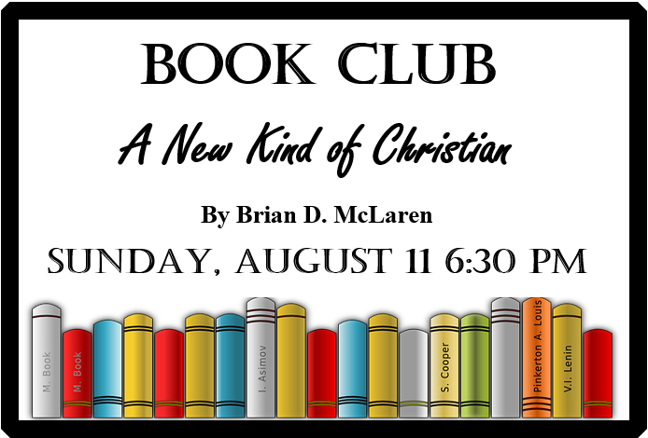

## **From the Pastor…continued from page 1**

Page 2

AUGUST 2019

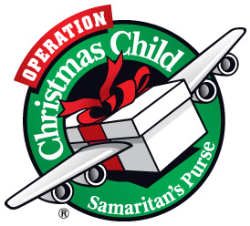

**HELP WANTED !**

**Benefits include:**

**-instant hero status**

**-all you can eat**

**Goldfish crackers**

**-unlimited high fives**

**-free crayons**

**See Vickie Denman**

**to apply**

“Declare HIS glory among the nations.

Psalm 96:3

⁓ SUNDAY SCHOOL NEWS ⁓

The upcoming Sunday School year will begin on September 1 with Fellowship Breakfast provided by the C.E.C. Classes for the new year have been set with classes for everyone!

**Sunday School teachers are:** Nursery – Cil Krcha, 2 yr to PreK – Judy and Jana Jeske, First & Second – Sandra Dubcak, **3rd & 4th grade –** **TEACHER NEEDED**, 5th, 6th, 7th – Mary Herridge *(there is a possibility of having a Confirmation Class so this class could change.)*  8th through High School – Tracie Malovets.

The three ADULT classes will continue with John Brinkley and Taylor Brinkley, RoseAnne Groseclose and Keith and Shannon Caldwell.

**Please prayerfully consider if you are called to teach the 3rd & 4th Grade Class.**

**Sunday School officers are**: Superintendent Vickie Denman, Assistant Superintendent Chelsey Pierce, Secretary Stacie Sebek and Treasurer Lynne Cassens.

The Sunday School is self-sustaining. It is not funded through church tithes so an offering is taken in each class.

The Craft Retreat was a great success! Ocker received tons of Praise from the 43 who were in attendance for the wonderful food and fellowship. There are so many folks who helped prepare meals, set-up, and clean-up!! It definitely was a group effort.

THANK YOU ALL!

**NOW**

IS A GREAT TIME TO PURCHASE SCHOOL SUPPLIES FOR SHOEBOXES!

Other items to purchase:

Soccer ball with pump

Dolls

Toy cars

Jump ropes

Yo-yos

Light up toys

Socks

Hats

Hair accessories

### Quarterly Craft Retreat – Success!

Page 4

AUGUST 2019

Childrens Choir

Music Ministry

Sunday, August 4

“Jesus Loves Me”

&

“Head, Shoulders, Knees and Toes”

AUGUST BIRTHDAYS

1 – Candice Henderson 15 – Marcia Snyder

Travis Glaser Emma Ranly

2 – Emily Doney 16 – Cil Krcha

Rosalie Speckhals 18 – Landon Kleypas

6 – Zane Deaver 19 – Grace Jungmann

Cory Pierce 20 – John Brinkley

Ryder Kleypas Chris Tucker

8 – Jaylea Elkins 21 – Karly Stephens

9 – David Coufal 23 – Janet Hoelscher

Jean Coufal 29 – Stephanie Phillips

9 – Ian Ranly 30 – Tommy Ruffino

10 – Dusty Deaver 31 – Shirley Marek

11 – Ray Coots

12 – Trevor Coots

13 – Gabbey Dillard

14 – Joe Dubcak

**CHRISTIAN SISTERS**

will meet 2nd Tuesday,

August 13 @ 6:15 pm. ALL women are welcome!

**We’re on the Web!**

**www.ockerbrethrenchurch.org**

**Twitter: @ockerchurch**

**&**

**Facebook!**

Phone 254.985.2240

E-mail ockerbrethrenchurch@

gmail.com

**Pastor:**

Dr. Brad Herridge

**Phone**:

254..716.2578

**Email:** bradherridge@gmail.com

**Board of Elders President:**

Keith Caldwell

**Phone:** 254-760-1340

**Email:**

caldwell1749@yahoo.com

**Youth Director:**

Jennifer Chervenka

**Phone:** 254-913-1244

**Email:**

jennchervenka@gmail.com

**Sunday School Supt.**

Vickie Denman

Phone:

254.217.0897

Email: denmanhouse1989

@yahoo.com

**Church Secretary:**

Stacie Sebek

Phone:

254.718.5608

ockerbrethrenchurch@

gmail.com

August Anniversaries

6 – John & Kim Dillard

12 – Jordan & Emily Sebek

13 – Richard & Phyllis Lesikar

15 – James & Mildred Wentrcek

21 – Ed & Doris Klinkovsky

26 – Barton & Tammy Pierce

Ocker Brethren Church

17454 State Hwy 53

Temple, TX 76501

**MAILING ADDRESS:**

P.O. Box 806

Rogers, TX 76569

AUGUST 2019

Page 5